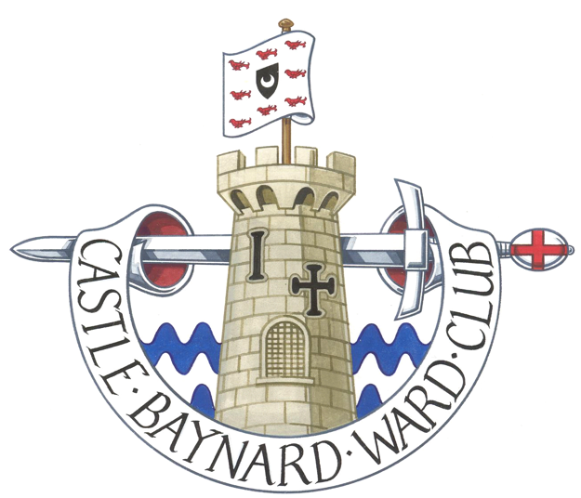**CASTLE BAYNARD WARD CLUB**

President: Alderwoman Martha Grekos

Hon Secretary George Godfrey

[www.cbwc.org.uk](http://www.cbwc.org.uk)

## REQUEST FOR CLUB REGALIA

|  |
| --- |
| Click or tap here to enter text. |

Title of Member (Mr/Mrs/Miss/Ms/Other)

|  |
| --- |
| Click or tap here to enter text. |

Name

|  |
| --- |
| Click or tap here to enter text. |

Despatch address & post code

|  |
| --- |
| Click or tap here to enter text. |

|  |
| --- |
| Click or tap here to enter text. |

|  |
| --- |
| Click or tap here to enter text. |

|  |
| --- |
| Click or tap here to enter text. |

|  |
| --- |
| Click or tap here to enter text. |

Home telephone number

|  |
| --- |
| Click or tap here to enter text. |

Mobile Telephone Number

|  |
| --- |
| Click or tap here to enter text. |

Personal Email Address (for confirmation)

I should like to order the following items:

Men’s Club Tie (Number)    @ £17.50

Ladies’ Club Brooch (Number)    @ £25.00

Costs above include postage

Please complete this form and email to: [**membership@cbwc.org.uk**](mailto:membership@cbwc.org.uk)

You will be advised by email on payment instructions.