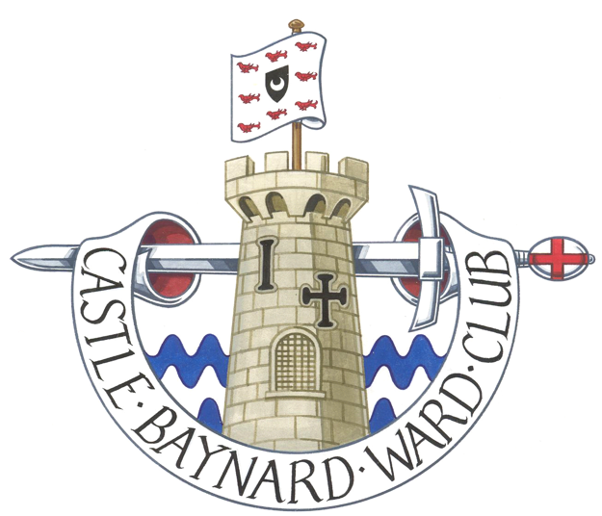
CASTLE BAYNARD WARD CLUB

President: Alderwoman Martha Grekos
Hon Secretary George Godfrey
www.cbwc.org.uk

APPLICATION FOR MEMBERSHIP

Click or tap here to enter text.
Title of Applicant (Mr/Mrs/Miss/Ms/Other)
Click or tap here to enter text.
Name in full

Click or tap here to enter text.
Decorations and Qualifications

Click or tap here to enter text.
Name of workplace

Click or tap here to enter text.
Address of workplace and post code

Click or tap here to enter text.

Click or tap here to enter text.

Click or tap here to enter text.
Work Telephone Number

Click or tap here to enter text.
Occupation

Click or tap here to enter text.
Private Address and post code

Click or tap here to enter text.

Click or tap here to enter text.

Click or tap here to enter text.
Home telephone number

Click or tap here to enter text.
Mobile Telephone Number

Click or tap here to enter text.
Personal Email Address *

Reason for application/ward connection (F1Help)

Upholder ☐ or Blacksmith ☐ or Spectacle Maker ☐ or United Wards Club Member ☐

* will be used for all Ward Club communications

Click or tap here to enter text.
Name of Proposer

Click or tap here to enter text.
Name of Seconder

Both of these must be current members of the Ward Club and at least one a current member of the Committee.

Please complete this form and email to: membership@cbwc.org.uk

